
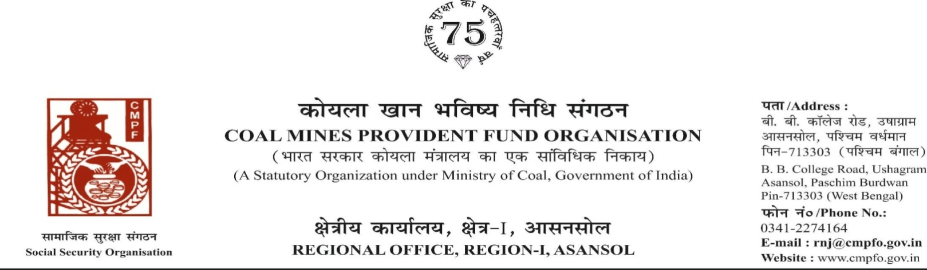
Ref. No. – C.P.F./111/Pen.Sec/R-1/ASN/ | Dated -01-07-2025
Reminder - II

OFFICE NOTE

It has come to the notice of the undersigned that the settled P.P.O.pension files have not been handed over to the Pension Section regularly.

All Dealing Assistants are hereby directed to submit all the settled P.P.O. pension files,which are kept with them and had not been submitted in thePension Section till date, within 5 (Five) days of issue of this office note.

Further, all the Dealing Assistants are also directed to submit the settled P.P.O. pension files of each month to Pension Section in the next corresponding month positively.

S.O. And A.O. Section lncharge are also directed to ensure that the settled P.P.O. files are handedover by the Dealing Assistants to the Pension Section positively after settlement of claim in same month.

( Apurva Kr.Pathak )
Assistant Commissioner – ( R-1 )

1. All Dealing Assistants for strict compliance
2. All S.O./A.O

